Master Functional Document

Application | NGERP - Centra
Service Bundle | Master Management
Service Request | Schedule

Description :

Schedule master is used to schedule the running time of the DB jobs.

Workflow Process :

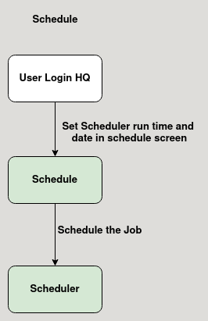

Business Rules :

- Schedule master is only editable in HQ.
- User can use this master to schedule the Database Jobs.
- User can choose the frequency, day and time to schedule the Job.
- This master is mapped to a scheduler.

